**19Z311-OBJECT ORIENTED PROGRAMMING LABORATORY**

**JAVA PROJECT REPORT**

**BATCH:- 4**

**TOPIC:-** STUDENT ATTENDANCE TRACKER

**GROUP MEMBERS:-**

HARINI.S(19Z317)

JAYASREE.B.S(19Z322)

SELVA KEERTHANA(19Z346)

NIVEDHA.K(19Z336)

ILAKIYA POOJA(19IZUS011)

PRAVEK DHINA(19IZUS013)

**PROBLEM STATEMENT:**

“ATTENDANCE TRACKER” is a program / software developed in java for maintaining the attendance of the students on daily basis in college. It facilitates to access the attendance information of a particular student in a particular subject and also in all subjects. This system also helps in evaluating attendance eligibility criteria of a student.

**CLASS DIAGRAM:**

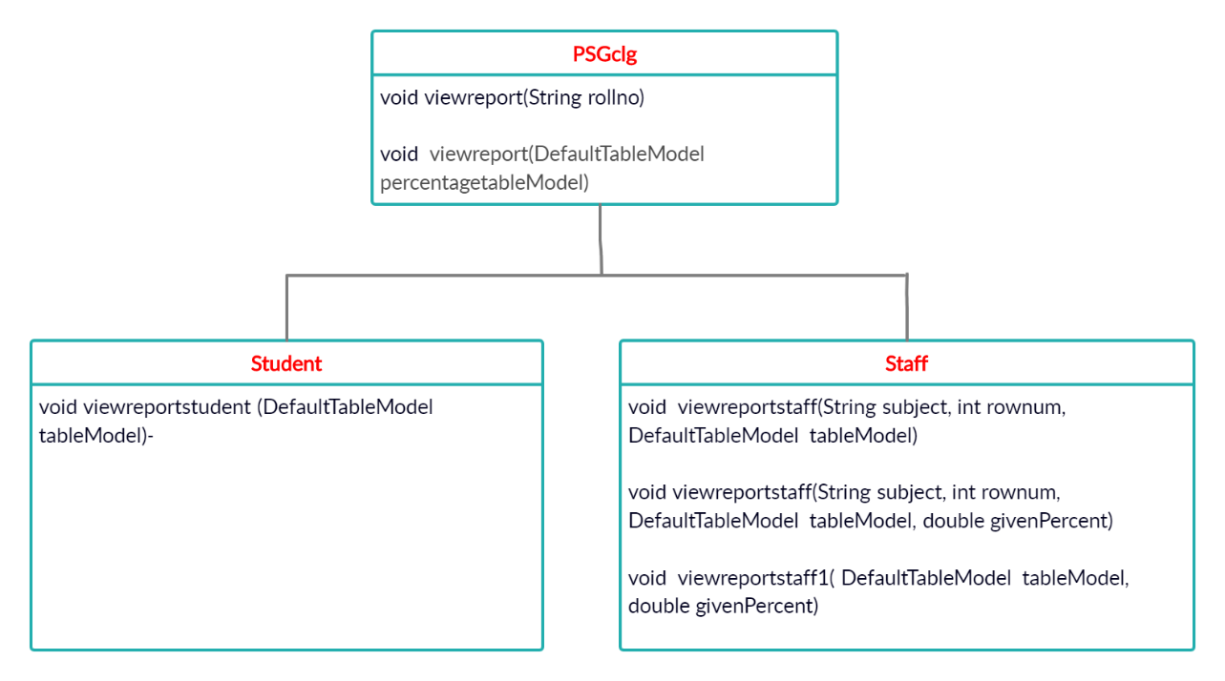

**USERS:**

* Staff
* Student/Parent

**FEATURES AVAILABLE TO THE USERS:**

In our program, The attendance of the students can be viewed in six different views by a staff. A student can view his/her attendance in two different ways. The user can view the number of late, excused and unexcused absence and also the present percentage.The attendance percentage is calculated by dividing the number of hours present by total number of hours (varies from subject to subject) multiplied by 100.

The six different ways of viewing by staffs are

* **FILTER BY STUDENT**

**Input:** Student’s Roll number

**Output**:It displays the name, roll number, present percentage of the given roll number in all subjects in the table format.

* **FILTER BY SUBJECT**

Input: Subject name

**Output**:It displays the name, roll number, attendance percentage, present, absent, excused leave and unexcused leave of the all the students in a class for a given subject.

* **VIEW FOR A PARTICULAR SUBJECT FOR A PARTICULAR STUDENT**

**Input**: Subject name and Student’s Roll number

**Output**: It displays the name, roll number, present, absent, excused leave, unexcused leave and the attendance percentage of the given roll number in the given subject.

* **FILTER BY STUDENT-PERCENTAGE - GIVEN SUBJECT**

**Input**: Percentage below which you want the details and Subject name

**Output**: It displays the roll number, present, absent, excused leave, unexcused leave and the attendance percentage for the students whose attendance are below the given percentage in the given subject.

* **VIEW ALL STUDENTS ALL SUBJECTS-PERCENTAGE**

**No input**

**Output**: It displays the name, roll number, attendance percentage of all students in all the subjects.

* **DISPLAY STUDENTS WHO LACK ATTENDANCE ALONG WITH THE SUBJECT**

**Input**: Percentage

**Output**: It displays the name, roll number, subjects, attendance percentage of the respective subject of all the students whose attendance are below the given percentage in all subjects.

The two different ways of viewing by a student are

* **VIEW PRESENT, LATE, EXCUSED AND UNEXCUSED LEAVE, PRESENT PERCENTAGE**

**Input**: Student’s Roll number

**Output**:It displays the subject name, present, absent, excused leave, unexcused leave and the attendance percentage of the given roll number in all the subjects.

* **VIEW ONLY PERCENTAGE**

**Input**: Student’s Roll number

**Output**:It displays the roll number, name, attendance percentage of the given roll number in all the subjects.

In our program after choosing the user, you can view for one particular month or for all months (August,September,October)

1. August
2. September
3. October
4. All

**CONTRIBUTION OF TEAM MEMBERS:**

|  |  |
| --- | --- |
| Harini.S | PSGclg constructor+ void viewreportstaff1(DefaultTableModel tableModel, double givenPercent) in Staff class |
| Jayasree.B.S | viewreport(String rollno)+ viewreport(DefaultTableModel percentagetableModel) in PSGclg class+Driver class |
| Selva keerthana.B.G | Student class |
| Nivedha.K | viewreportstaff(String subject, int rownum, DefaultTableModel tableModel, double givenPercent) in Staff class |
| Ilakiya Pooja | viewreportstaff(String subject, int rownum, DefaultTableModel tableModel) in Staff class |
| Pravek Dhina | Report work |

**CHALLENGES FACED:**

* Displaying the details in the table format.
* Reading from the csv file.

**SNAPSHOTS OF THE OUTPUT:**

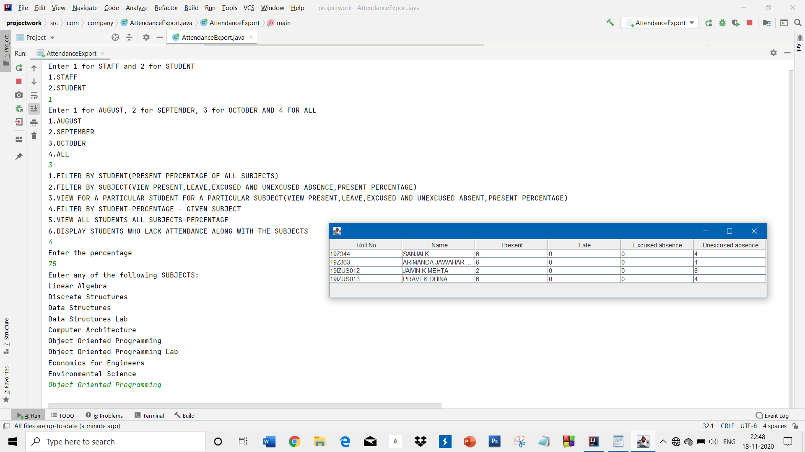

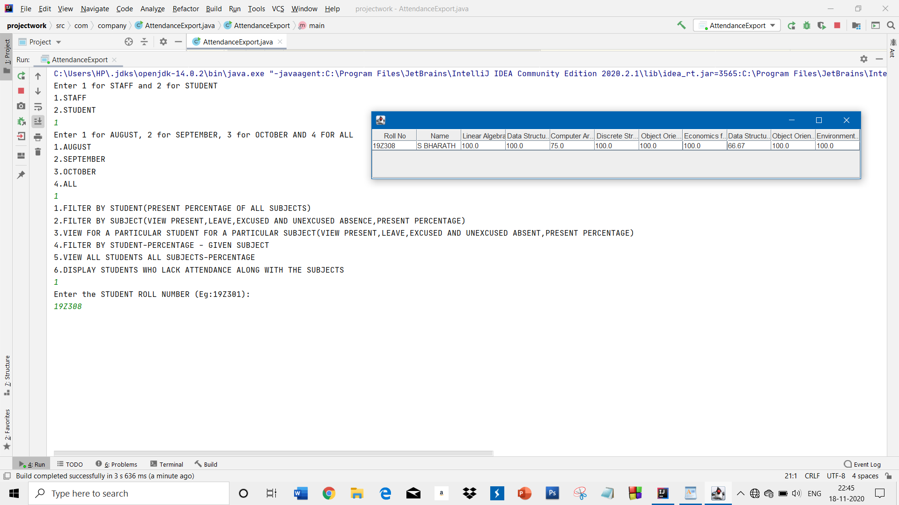

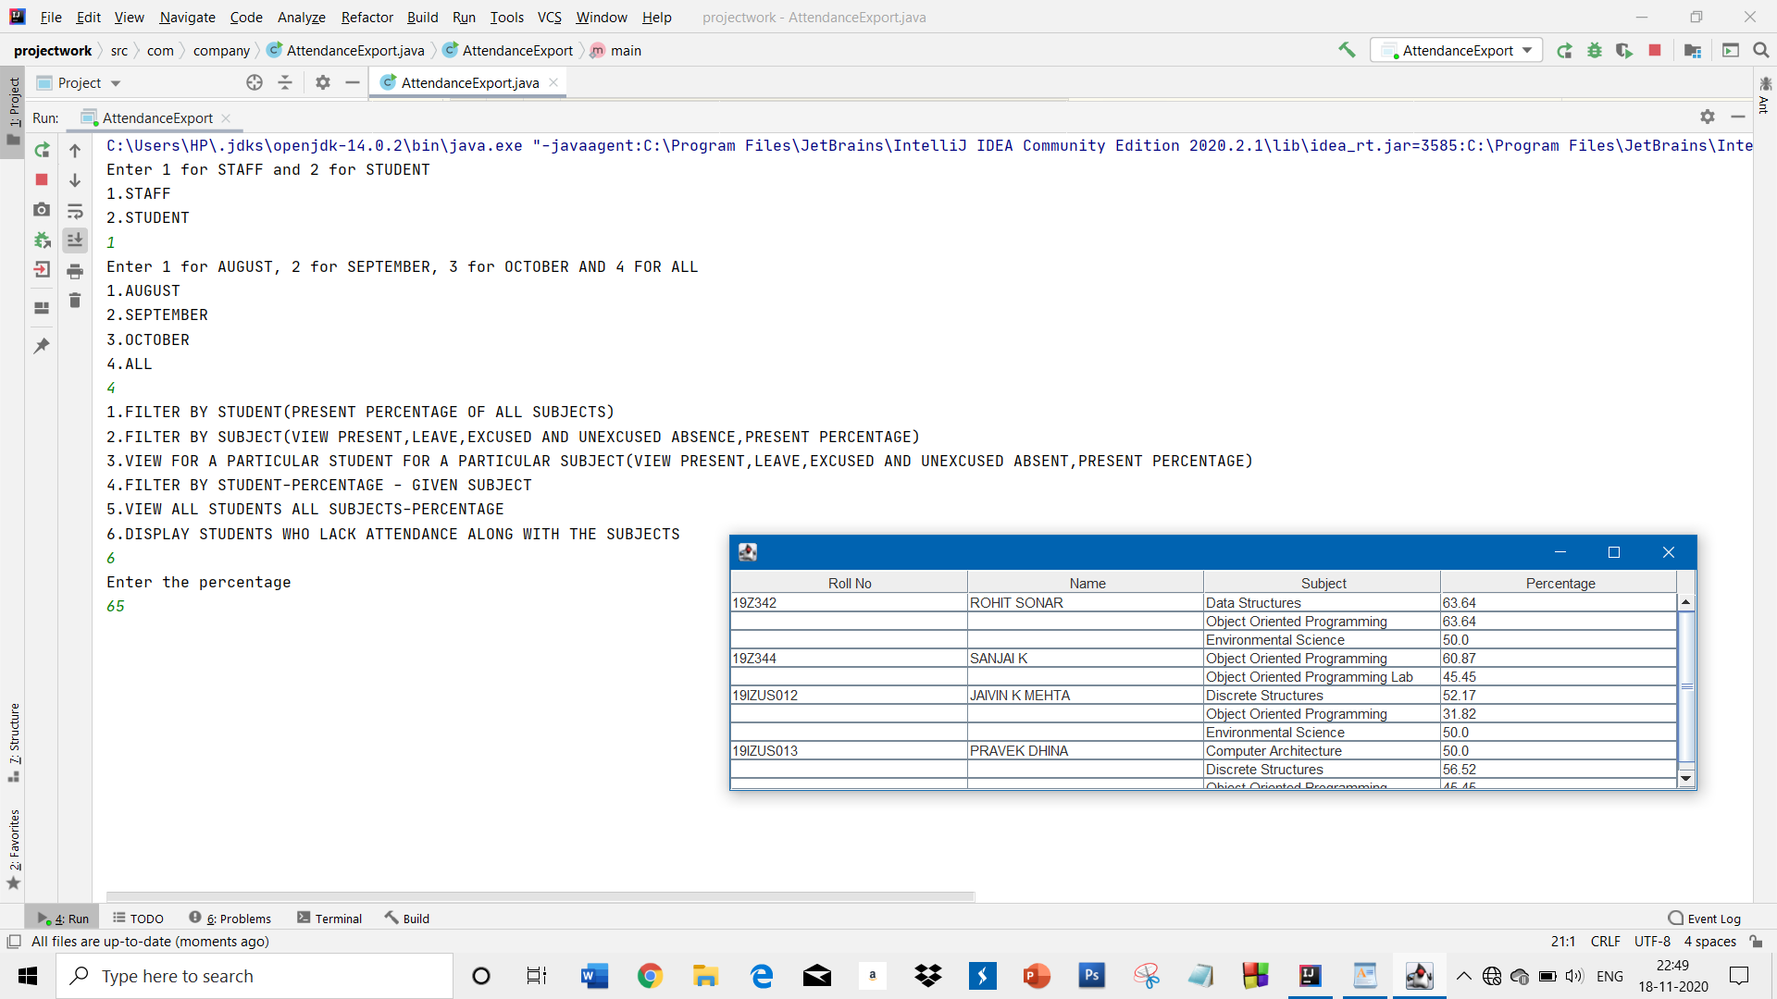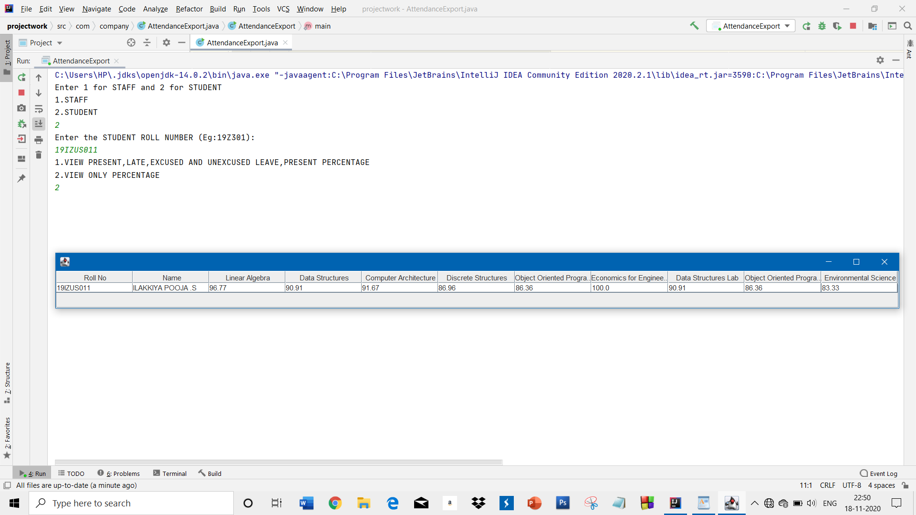

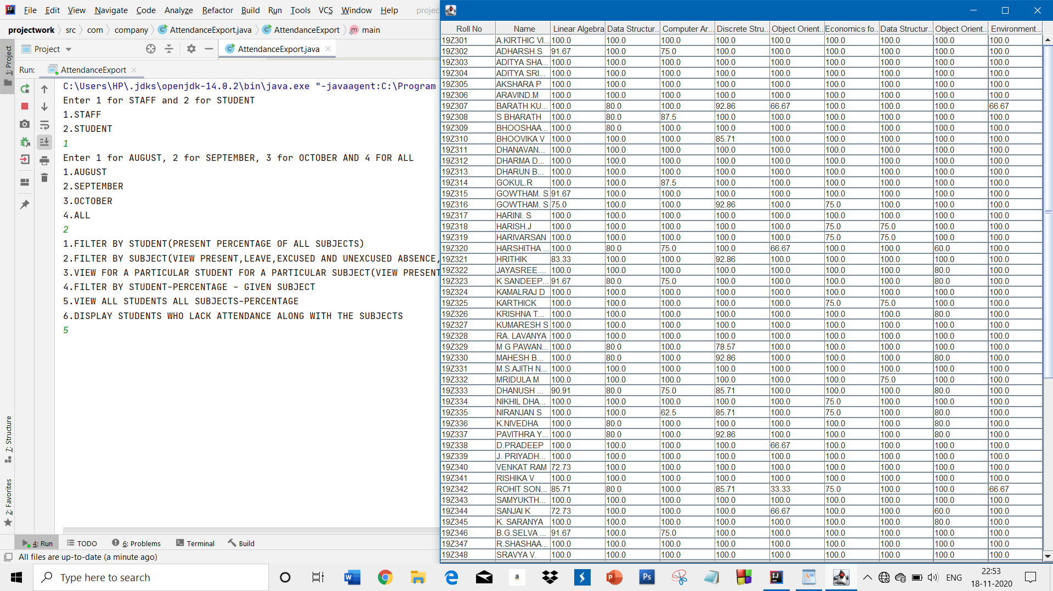**CODE:** [**https://github.com/Harini-19Z317/java-attendance-tracker/blob/master/src/AttendanceExport.java**](https://github.com/Harini-19Z317/java-attendance-tracker/blob/master/src/AttendanceExport.java)

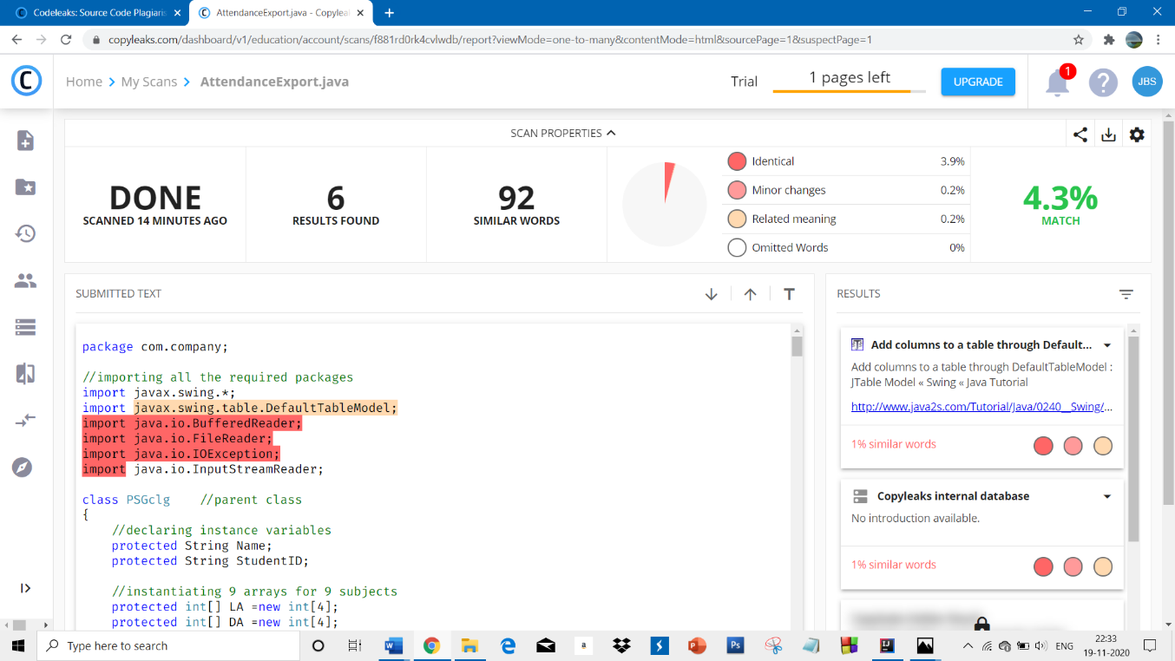**PLAGIARISM REPORT FOR THE CODE:**